

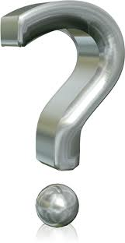
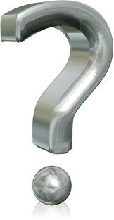
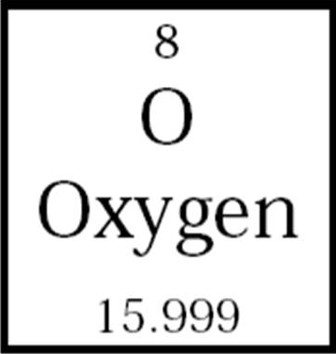

- Dead or alive -
Element name here
- Characteristics -
WANTED!
Also known as “ (insert any alias here)”
- Classification: _____________________________
- Melting Point: ______k / Boiling Point: ______k
- Phase at room temperature: (Gas,liquid,soild)
- Born: _____, (where?)/ Parnet: (discovered BY)
- beware Armed and dangerous -
- Is this element dangerous or hazardous?
- Know hideouts & Accomplices: (where in daily life can you find this element? What other elements can be found with it in substances?)

